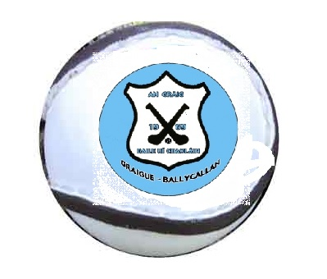
DECLAN BYRNE TOURNAMENT
SUNDAY 12TH June 2016

RULES:
- 15 players on a team
- 2 x 20 minutes
- Normal hurling
- In the event of a draw there will be 10 minutes extra time consisting of 2 x 5 minutes.

- In the event of a draw after extra time the winner will be decided by 5 x 65’s per team. The team to score the most will be deemed the winner.

GUIDELINES:

- First Groups will play at 10:00am

- Second Groups at 11:00am.

- There will be a Cup and a Shield Final so each team will have a minimum of two games.

- There will be refreshments available during the day to teams, mentors and supporters.

- Details will be available on the GraigueBallycallan website

  - http://www.graigueballycallan.ie/

Martin Delahunty
086 1956986

