St. Brigid’s Camogie Club

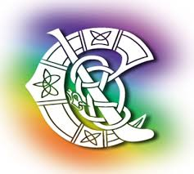

The Annual General Meeting of St. Brigid’s camogie club will take place on 25th November 2016.

Nominations are now being accepted for the following positions for 2017 – Chairperson, Vice-Chairperson, Secretary, Assistant Secretary, Treasurer, Registrar, PRO and Health and Safety Officer.

Position being nominated for: ________________________________
Name of person being nominated: ________________________________
Name of proposer: ________________________________

Only full members of the club can nominate other members. Also, please check/ensure that the person you nominate is a current member of the club and is aware that he/she is being nominated for the position.
All nominations to be sent in writing to Carmel Brennan, Secretary St. Brigid’s Camogie Club, Ballycuddihy, Kilmanagh, Co. Kilkenny by Tuesday 15th November.

