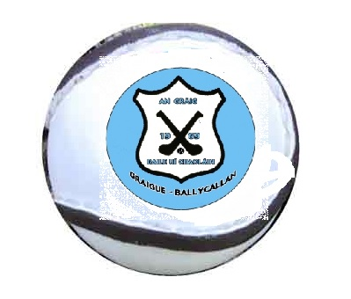
DECLAN BYRNE TOURNAMENT
Sunday 30th July 2017.

RULES:
- 15 players on a team
- 2 x 20 minutes
- Normal hurling
- In the event of a draw there will be 10 minutes extra time consisting of 2 x 5 minutes.

- In the event of a draw after extra time the winner will be decided by 5 x 65’s per team. The team to score the most will be deemed the winner.

GUIDELINES:

- First Group will play at 11:00am

- Second Group will play at 12:00am.

- There will be a Cup and a Shield Final so each team will have a minimum of two games.

- There will be refreshments available during the day to teams, mentors and supporters.

- Teams taking part:

- Graigue-Ballycallan

- Danesfort

- Fenians

- Harps, Durrow

- Ballingarry, Tipperary

- Glenmore

- Lisdowney

- O’Loughlin Gaels

We look forward to welcoming players, mentors, parents and supporters to Tom Ryall Park, Kilmanagh on this Sunday and hope that you will all enjoy your day as we honour our late Club Juvenile Member, Declan Byrne.
Thank you.

