MATCH THE LEGS TO THE FACE

€2 PER ENTRY OR 3 FOR €5

Match which pair of legs you think belong to the face. Place a, b or c etc in the space provided beside the picture. For 3 entries use all 3 boxes.

Please return entries to hurling and camogie trainers by Thursday 23rd August with name and contact number (space on back page)

Winners will be announced at the Shave, Wax or Dye event which will be held in Brennan’s Bar on the 25th August.

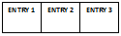
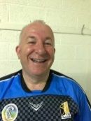
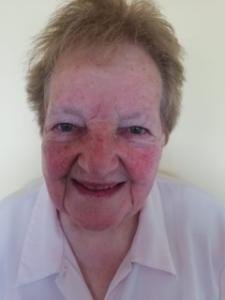
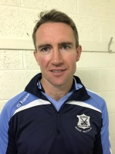 Eddie Brennan Adrian Ronan
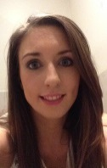 Amy OConnor James Ryall 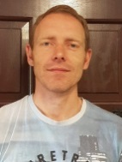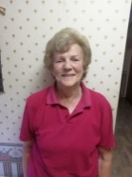Nellie Ryall Fr Liam Taylor 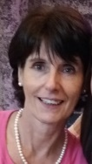 Geraldine Dunphy Mary Egan 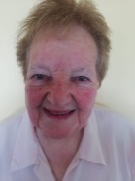 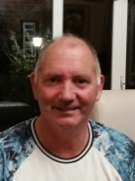 John Cahill Emma Boland
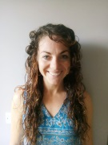 Therese Muldowney Billy Ryan 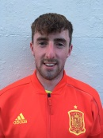VOTE FOR:
THE LOVELIEST LEGS ___________________ (picture No)
THE KNOBBLIEST KNEES ___________________ (picture No)
THE LOVELY LEGS!
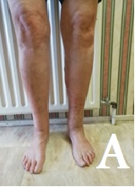
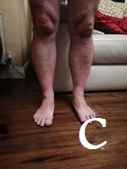
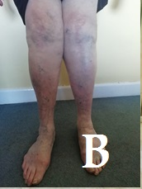

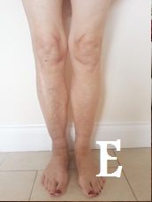
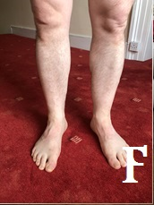
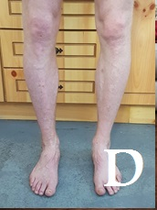

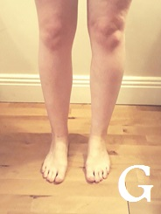
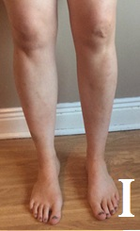
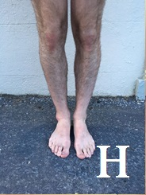

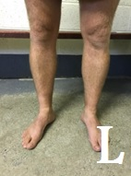
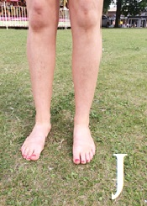
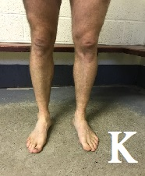

PRIZES:
Adult Prizes:
- Meal for 2 at Rive Gauche (value €100)
- Meal for 2 at Lyrath Hotel (value €90)
- Ballykeefe Distillery Bottle of Gin (value €50)
Juvenile Prizes:
- Coaching session with some of our heroes Eddie Brennan, James Ryan, Billy Ryan and Aisling Dunphy.
- Family Meal at Eddie Rockets
- Sports Voucher

Name: _____________________
Contact Number _____________________
Team (Age Grade eg U6) _____________________
For juvenile only

This is a fundraiser to support my upcoming entry into Lipsync 2018 to raise funds for the development of the pitches of GraigueBallycallan GAA and St. Brigid’s camogie club

John Cahill
087 2892873

