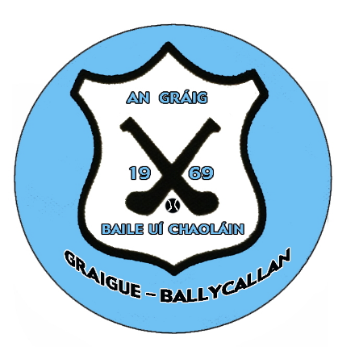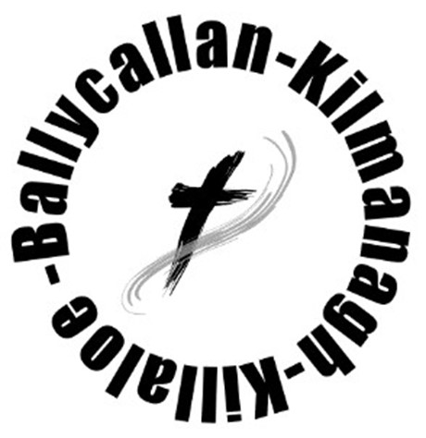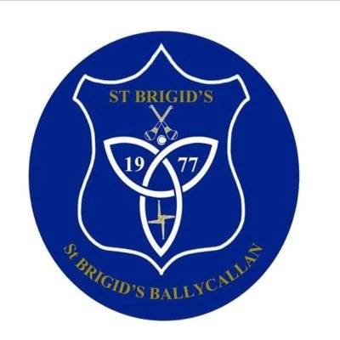
The LOTTO: Ensuring our future for the next four years.
Since its inception over 30 years ago, the Parish/GAA Lotto has been a huge success and a valuable source of income for both parties. After it’s suspension during the Covid Pandemic it was re-launched in 2021 with the agreement from the Ballycallan Parish to turn over 100% of the proceeds to GBC for two years to assist with the funding of its developments.
Massive local support was garnered, which resulted in badly needed revenue being generated to help service the associated debt accrued by the delivery of the following projects: 1 : A new Gym and multi-function social/fitness area, 2 : a Floodlit Walkway, 3 : Refurbishment of the existing Club House, 4 : Six Ball Stopping Nets and 5 : a New Mower. The total Cost of these ambitious projects which benefit the boys of GBC, the girls of St. Brigid’s and the whole community was €465,000 with a debt of €131,000 now outstanding.
We want to keep our promise to repaid this in a timely manner while still continuing to meet the daily costs of running successful adult and juvenile clubs.
Consequently, a new fund-raising agreement has been reached with our partners the Parish of Ballycallan that for the next four years, the vast majority of the funds generated from the Lotto will continue to be directed towards the paying off of this debt each year, with the remaining funds going to the running of the Ballycallan Parish.
Both clubs are extremely grateful to Fr. Taylor and his Committee for this generous display of confidence in our clubs and their recognition of the important part the enhanced facilities in Tom Ryall Park continue to play in the social life of our Parish.
Of course, the success of our Lotto depends on the continued support we receive from our fellow club St. Brigids, our fifty local promotors from both Clubs and the Parish Committee. To all of our players who contribute each week to the Lotto, without you the facilities at Tom Ryall Park would not be in place today.
Over the next few weeks our promotors will be contacting you and it is our hope that you will continue to support both the Hurling and Camogie Clubs and the Ballycallan Parish as you have always done in the past.
Thank you.
Dave O’Neill Fr Liam Taylor
Chair Graigue-Ballycallan GAA Club Parish Priest
Michael Malone
Chair St. Brigid’s Camogie Club

